WHAT ARE FRAMING and REFRAMING?
Framing and reframing are communication techniques that facilitate dialogue by helping people identify and articulate their interests and relate them to a shared problem, challenge, or opportunity, i.e., an issue of mutual concern. These techniques are fundamental components of active listening and are most effective when combined with other behaviors and techniques that allow people to feel heard, communicate clearly, and build shared understanding.

FRAMES & FRAMING
A frame is how someone conceptualizes themselves, others, or the world around them. Frames shape every person’s viewpoint and can be influenced by physical context, life experiences, and culture. Framing is the intentional application of a frame to an idea or perspective to impact how it is perceived (e.g. the froyo contains 20% fat vs. the froyo is 80% fat free).

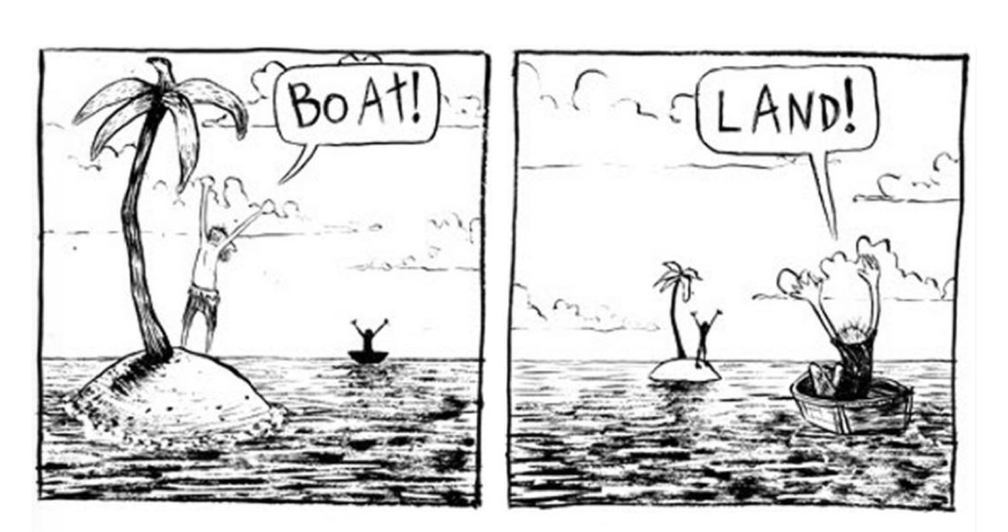
REFRAMING
Reframing is restating an idea or comment to center the issue of mutual concern and interests, while respectfully acknowledging the speaker’s underlying emotions and concerns. The two characters in the comic to the left have different frames that reflect their points of view. What do you think is their issue of mutual concern, and how might you reframe their exclamations to highlight it?

WHEN IS FRAMING AND REFRAMING USEFUL?
Intentional framing can be useful for helping a conversation focus on the issue of mutual concern, supporting dialogue, building coalitions, and convincing a broader audience of the value of a certain action or outcome (e.g. funding a situation assessment or convening a collaboration). Reframing is a tool for addressing problems that cannot be resolved using the terms in which they are presented. For example, reframing can help recast an intractable problem as something that can be solved or transform a complaint into either a request for action or a possible solution. Anyone can use framing and reframing to promote relationship-building and set the stage for collaboration. These techniques can:
- Clarify a comment
- Help someone move away from “positional” thinking
- Uncover or highlight a person’s interests
- Turn a complaint into a request for change or a potential solution
- Reveal an opportunity in a challenge

KEY COMPONENTS OF REFRAMING
PRO TIP: Frames are not one-size-fits-all.

The effectiveness of a frame varies with the context, including the cultures and personalities of those participating in a conversation and the setting in which the conversation is happening. Discussions in a packed courthouse will necessarily be different from those in a quiet living room.

The key is to determine which framing of the issue of mutual concern resonates with the person you are speaking with and is appropriate for the context.

- Listen carefully
- Identify the speaker’s underlying interests or concerns, and how they relate to the issue of mutual concern
- Summarize and clarify their perspective, as necessary
- Depersonalize the conflict
- Recognize the speaker’s underlying emotions and concerns
- Find the speaker’s positive intent
- Restate as the speaker’s concern about needs or fears

EXERCISE: REFRAMING IN ACTION
Round 1 (10 min): Find a partner, preferably someone you do not usually talk to. Spend five minutes working individually to reframe four of the five statements below. Then use the remaining five minutes to share your reframed statements with each other, explaining what you think the issue of mutual concern might be and the functions your reframed statement serves (e.g. clarification, highlighting interests, turning a complaint into a request for change). If done in a group setting, be ready to share insights with the group.
- I know the National Park is overcrowded, but a reservation system for getting into it is a terrible idea. That would devastate the local economy and visitors would hate it. There’s no way I would support that.

- It’s clear that we have a regional water quality problem, but there’s no way the different cities are going to work together on a regional wastewater treatment plant. We talked about that years ago, and it was super contentious and went nowhere. It’s not even worth spending time on.

- Housing in this town has gotten way too expensive! Clearly, we need to make it easier to subdivide property so we can build more housing!

- A grizzly bear attacked a guide in front of the ranch last summer. What if it had attacked one of our guests?! We definitely need to start hunting the grizzlies, so they regain their fear of humans.

- I’m so overwhelmed! I really like my job, but if things don’t slow down, I think I may have to quit.

Round 2 (15 min): You and your partner will practice reframing each other’s statements. For five minutes, one of you should vehemently describe a frustrating situation you have faced recently, and the other will listen, acknowledge, and reframe what they heard. The storyteller will have two minutes to provide feedback to the reframer, then you will switch roles. Think about how it feels to have your ideas and feelings reframed and be ready to share insights with the group.

