WHAT IS A SITUATION ASSESSMENT?
A situation assessment is a recommended best practice first step in exploring the potential for collaborative solutions to an issue of mutual concern—i.e., a shared problem, challenge, or opportunity. Typically conducted by a facilitator or other neutral third-party professional, a situation assessment consists of background research and in-depth confidential interviews with a diverse range of key stakeholders. Situation assessments play a number of roles:
Bringing clarity to complex issues.
The confidential assessment process helps neutral party assessors understand the history and context of the issue of mutual concern and related challenges; identify key affected parties and their predominant interests; highlight areas of agreement and disagreement; explore opportunities and challenges for collaborative problem solving; identify key paths forward for better addressing the issue; and make unbiased recommendations for action based on this comprehensive understanding of the issue and related dynamics.
Photo: wocintechchat.com
Providing opportunities for voices to be heard.
Assessment interviews provide those with a stake in an issue an opportunity to share their perspectives and concerns. Often, this opportunity for involved parties to fully share their perspectives and “be heard” by a neutral party goes a long way, in and of itself, toward resolving conflict and advancing collaborative problem solving.
Helping to build mutual understanding.
The findings of a situation assessment are typically summarized in a report or a briefing that shares the key takeaways from interviews and background research impartially and without attribution. The report can act as a “boundary object,” helping to create mutual understanding about the issue of mutual concern, who should be involved in addressing it and how, key challenges and opportunities, and priority next steps.
WHEN MIGHT A SITUATION ASSESSMENT BE USEFUL?
Assessments can often benefit situations in which:
Issues cannot be solved by one party working alone, but rather require participation and commitments from others to ensure successful resolution;

Implementing solutions will involve concerted and coordinated efforts by many parties over time;

Issues are characterized by complexity, uncertainty, and interdependence; and/or

Issues are defined by multiple sets of facts or lack a clear and agreed-upon common information base.

POTENTIAL REASONS FOR CONDUCTING A SITUATION ASSESSMENT | POTENTIAL RISKS OF NOT CONDUCTING A SITUATION ASSESSMENT
- To better understand the circumstances and relationship dynamics related to an issue of mutual concern  - To identify key stakeholders involved with the issue of mutual concern and their interests  - To identify areas of agreement and disagreement related to an issue of mutual concern  - To assess opportunities and capacity for collaboration around an issue of mutual concern  - To help surface creative and innovative strategies for addressing the issue of mutual concern  - To assist stakeholders in developing shared understanding about an issue of mutual concern, key opportunities and challenges, and priority next steps  - To allow a third-party neutral to develop trust with stakeholders | - The problem-solving process takes longer, costs more, and/or is ineffective due to lack of appropriate process design  - Collaborative solutions are not reached because stakeholders do not trust each other and/or the process, or because key sources of conflict are not addressed  - Progress on the issue is inhibited because not all key stakeholders (including those with power to authorize, fund, block, or stall decisions and actions) are involved  - The problem-solving process is not effectively designed to help stakeholders generate innovative solutions and co-create mutual gains solutions  - Lack of shared understanding and/or assumptions about the issue of mutual concern preclude collaborative problem solving

HOW IS A SITUATION ASSESSMENT CONDUCTED?
The William D. Ruckelshaus Center developed the graphic below to show the typical steps and stages in a situation assessment. Assessments should be conducted by neutral third parties whenever possible to ensure affected parties can openly and honestly share their perspectives.
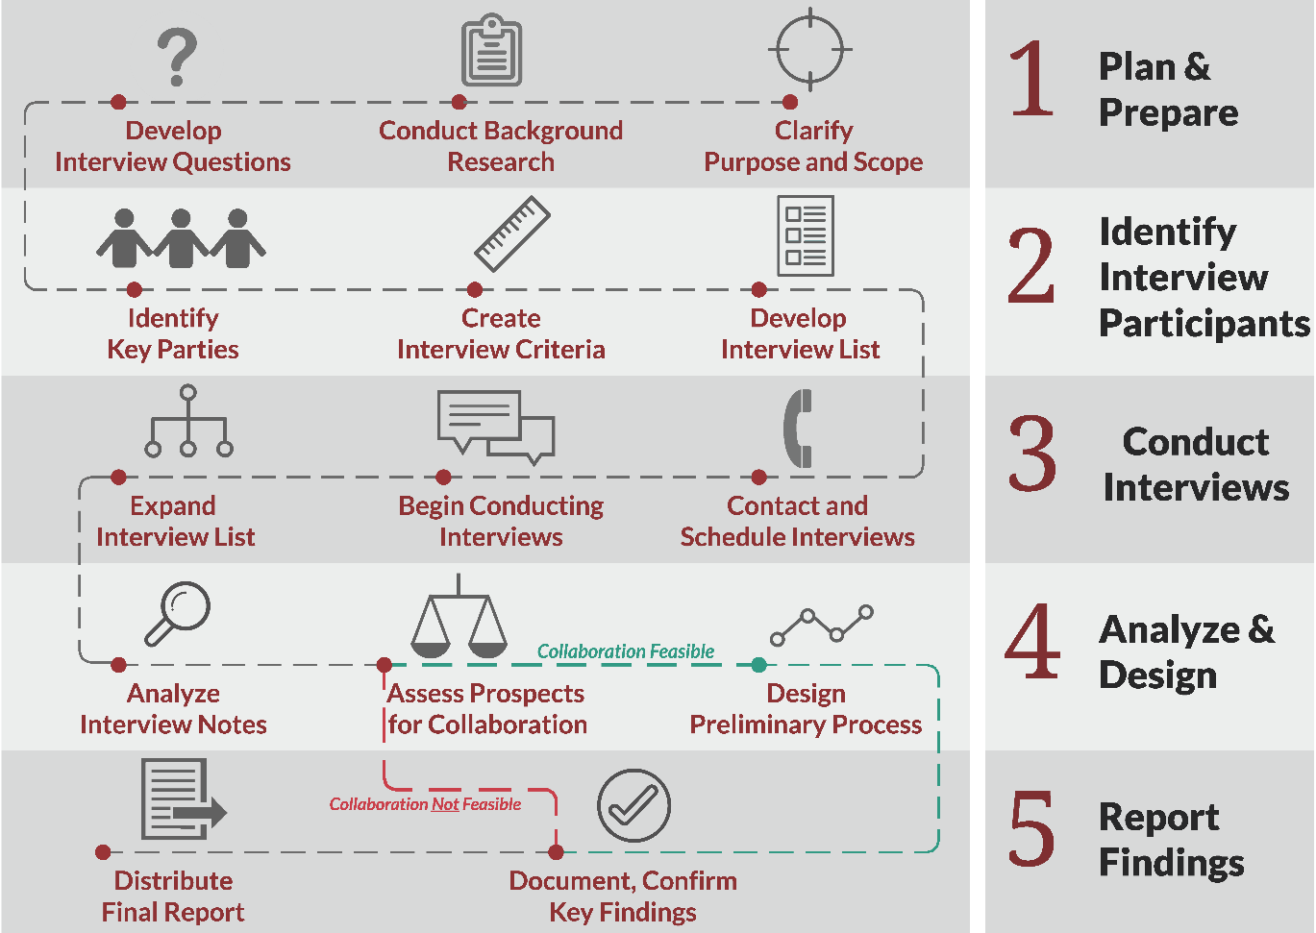
Stages and steps of a situation assessment. Designed by Amanda Murphy, The William D. Ruckelshaus Center.

